Sensory Systems in the Learning Environment
Classrooms are for Learning,
Hallways are for Displays
_______________________________________________________

Today’s tip looks at the idea of creating a balance within the classroom of ‘stimulation’ vs ‘overstimulation’ from a visual point of view.

We have all watched the trend of modern classrooms often losing this balance over the last 10-20 years for many different reasons:
- The need to display their work to eager parents, keen for a little visual feedback about how their kids are going,
- charts to remind children of what they have learnt,
- prompting tool for the skills that might need time to mature,
- ‘bump it up’ charts for the endless search to go one better,
- simply a need for more storage of resources means busy bookshelves and open cupboards,
- the list goes on!

What if there was a way that we could achieve all of these, but bring back the balance, through very careful design. It may cost a little in the beginning, but in the long term the benefits for both school and students would be enormous.
Here’s a few ideas to get you going that we have found effective:
- Doors for cupboards – sounds simple but often not built in OR often not closed.

- Keep colour of storage areas calm and simple – bright might be exciting, but it is more important for students to be excited about the worksheet.

- No hanging work - while the space up there often feels ‘underutilised’ and makes for a great ‘art gallery display’ the amount of attentional energy the average child needs to use to ‘ignore’ that stimulus means teachers are getting a reduction in the child’s % of focus on the new learning. As simple math goes, if we want to increase attention and focus to the now, we need to add up how much attention have we been responsible for taking with reflecting on the past.

- Set up the hallways and outside the classroom ready for displays from the start of the year. It will take some thinking and clever design ideas to have this set up to be user friendly to people and weather, particularly if the outside area is in the ‘outdoors’, but when done well the response from parents is very positive PLUS reduces the amount of parents wanting to enter the classroom at the end of the day.

- Think through the most valuable information to have out ‘now’ and make designated areas for these to be presented. Preferably these will be not near the whiteboard / blackboard, or within the ‘arc of arms’ concentration range for children when they are facing forward looking at the teacher. Putting these in small ‘learning nooks / areas will also help give the children a target of where to begin looking for the prompts. This is important as many children will often give up and prefer to ask a classmate as the search for the prompt was too hard to begin with.

  - Remember to consider the idea of cycling through posters of choice. Rather than having a selection of motivational posters or artworks in all areas of the room, have a “poster of the week” place. Changing this from time to time will create novelty and ensure that it is seen rather than tuned out as being just part of the larger visual clutter.

- If reflection on past work is important in the learning process, then use interactive white boards to create a slide show of artworks. This is something that can be put on in the background during quiet time or meditation times, or if parents are welcome into the room at the end of the day, rather than being constantly present on the walls or hanging across the room.
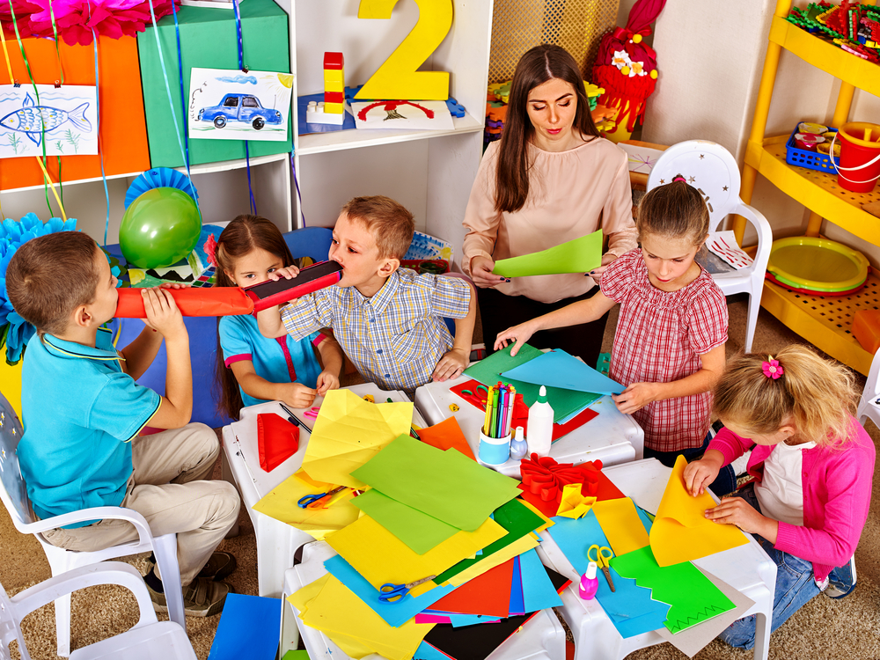

Want more ideas for this concept?
Reach out and let us know, we are more than happy to help problem solve!

Image: colours and clutter can be visually distracting

